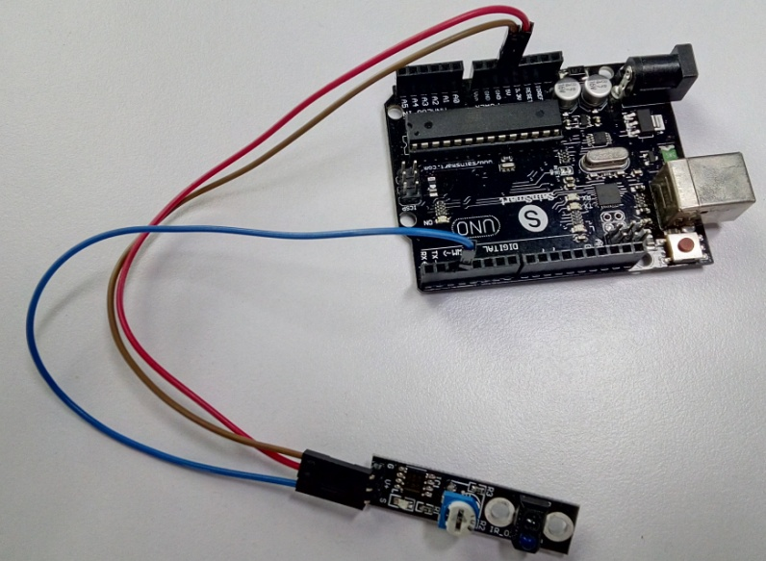

//The working voltage of 5V, black line output low level, white line output high level

int Led = 13 ;// define LED Interface

int buttonpin = 3; // define Tracking Sensor Interface

int val ;// define numeric variables val

void setup ()

{

pinMode (Led, OUTPUT) ;// define LED as output interface

pinMode (buttonpin, INPUT) ;// define Tracking sensor output interface

}

void loop ()

{

val = digitalRead (buttonpin) ;// digital interface will be assigned a value of 3 to read val

if (val == HIGH) // When the Tracking sensor detects a signal, LED flashes

{

digitalWrite (Led, HIGH);

}

else

{

digitalWrite (Led, LOW);

}

}